**Replicating VMs into AWS**

* [Refer Here](https://docs.aws.amazon.com/server-migration-service/latest/userguide/console_workflow.html) for the official docs
* Now From connector use server catalog to select the virtual machines for migration  
  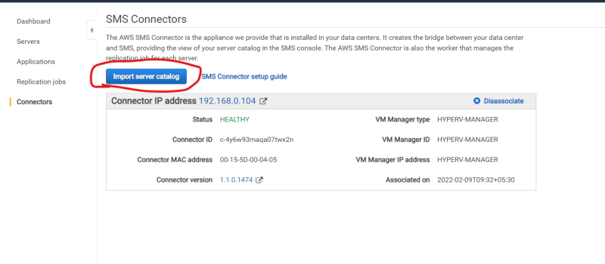  
  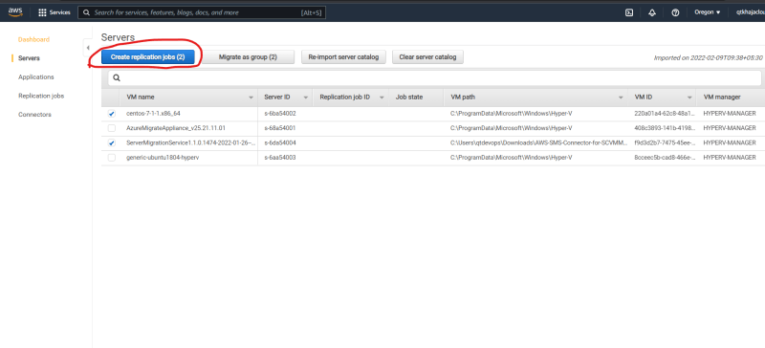  
  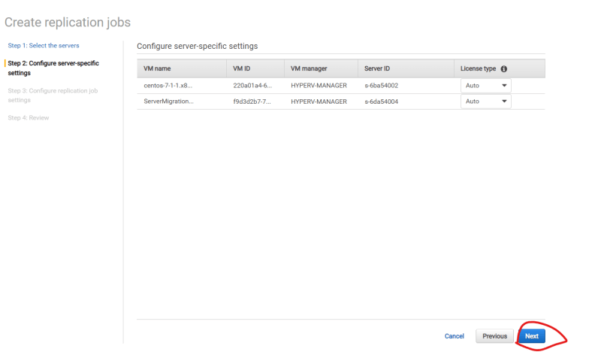  
  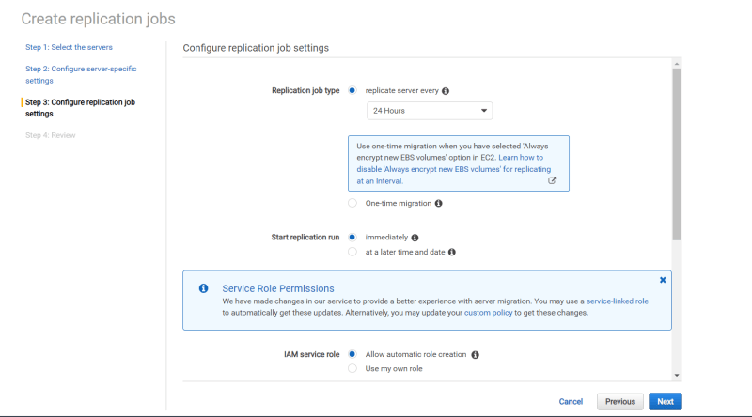
* But for the purpose of this class we would be using one time migration  
  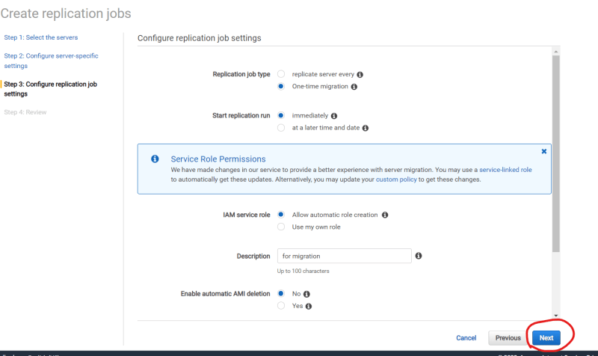  
  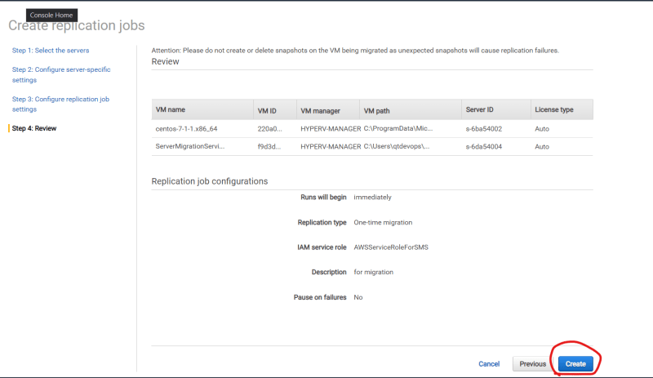
* Create a replication job and wait for the AMIs to be created, once the AMIs are created and replication job is successful.
* Create an ec2 instance with the AMI and verify the settings